**EXECUTION FLOW**

**Basically, we need to describe which test case needs to be executed first and which one next**

**We manage this in execution flow**

**In this example our Test Set consists book flight ticket and login tests**

**As it seems book flight ticket test is first**

**However, in order to book flight ticket, we need to login first**

**So, we need to define that login test needs to be executed first.**



**It now looks like all tests are executed at the same time**

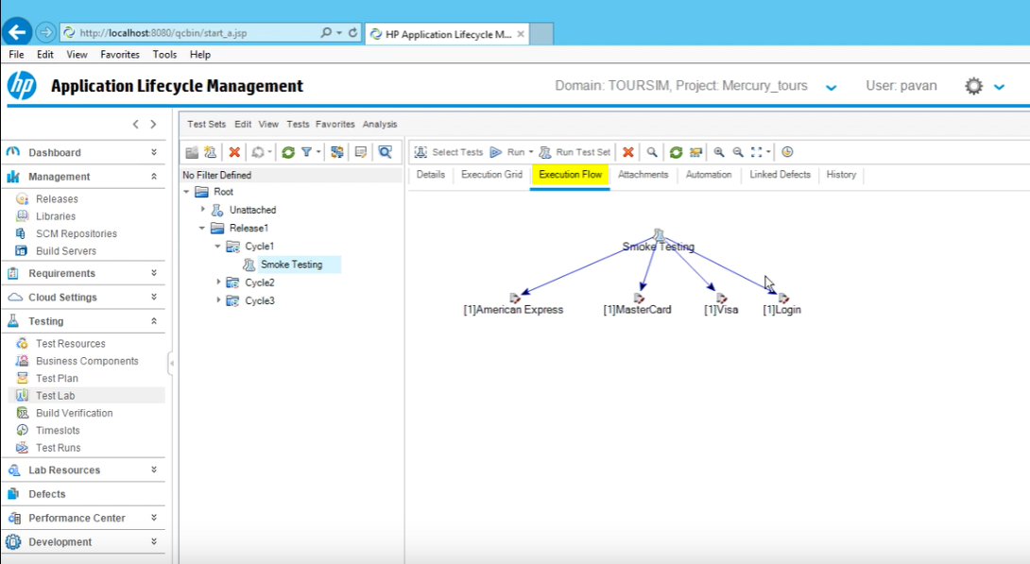

**Click on Test Run Schedule**

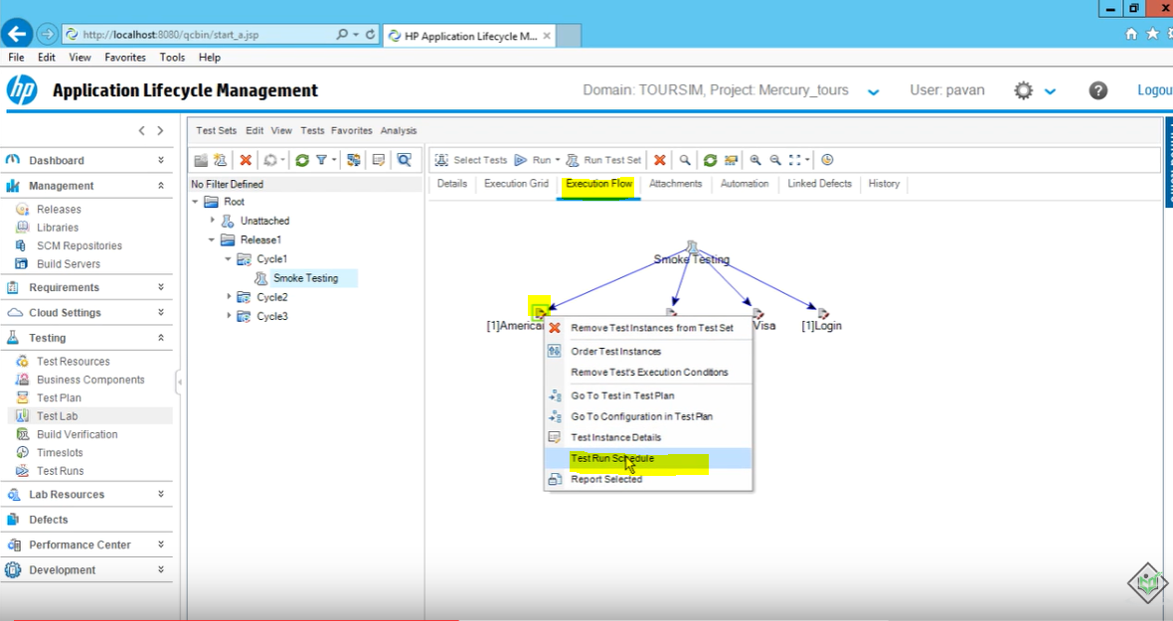

**Add Execution Condition**

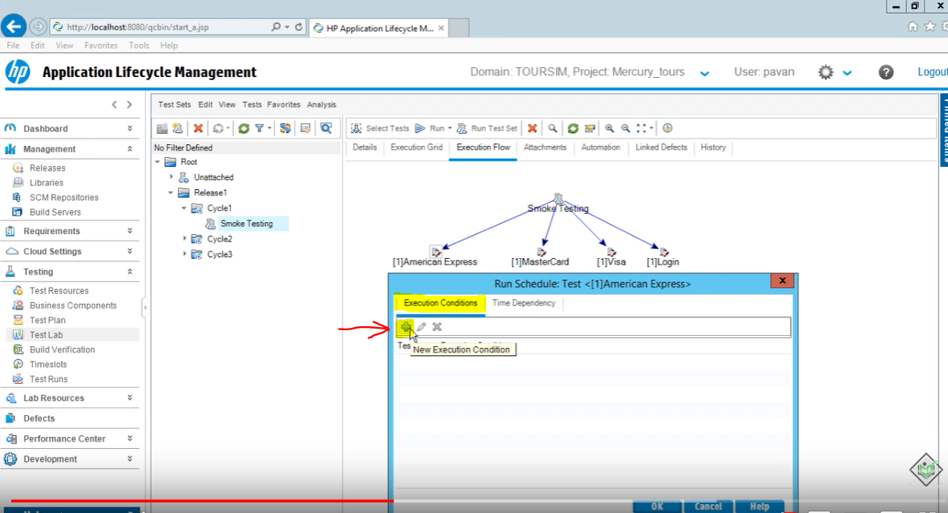

**Execution condition is American Express runs only if login is passed**

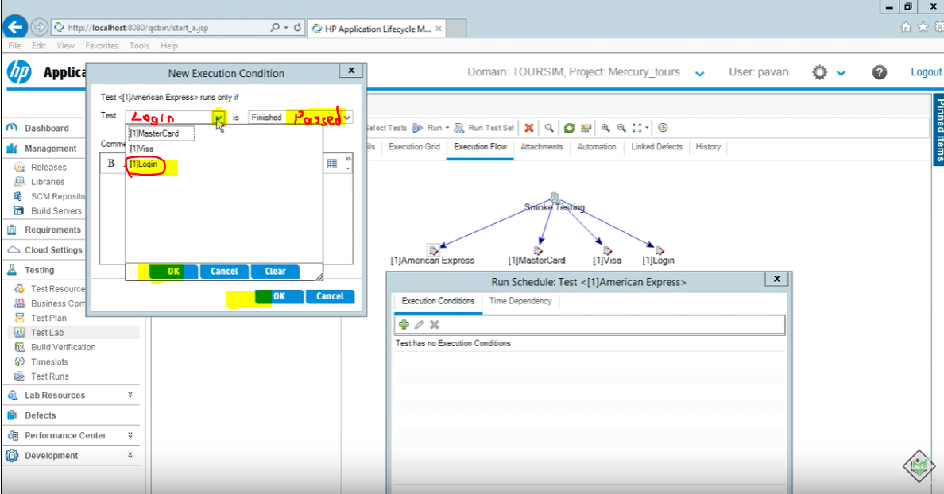

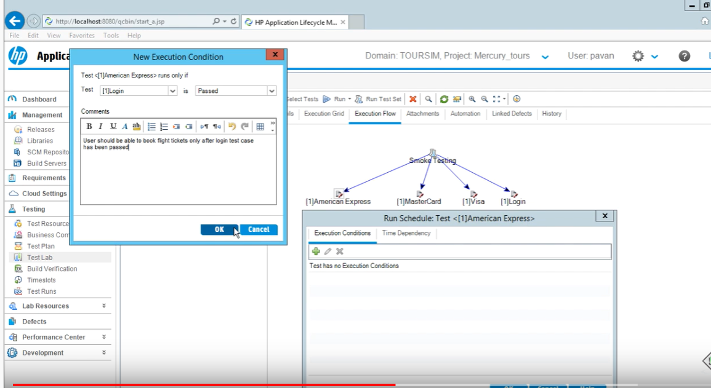

**Click ok, ok**

